
Cafeteria System


Team Members:-

Yousef Waleed Farid – 324243437@sha.edu.eg - 14B
Yousef Mohammed Ajeeb - 324243649@sha.edu.eg - 14B
Yousef Ebada El Said - 324243492@sha.edu.eg -14B
Yousef Refat Adly - 324243410@sha.edu.eg -14B
Yousef Ibrahim Abd El Ghani - 324243093@sha.edu.eg - 13B

System Description:
full-stack software system designed to enhance cafeteria operations at universities. Long queues, mistakes made when handling cash, and poor inventory management are all common problems. The system uses efficient back-end architecture and a cross-platform mobile application (Flutter) to bridge the gap between students and kitchen staff.

System Overview:
1. Student Mobile Application
- Menu Browsing: Categorized view of available items.
- Digital Wallet: A secure, closed-loop financial system where students pay using pre-loaded credits.
- Smart Ordering: Users can place orders with specific instructions (e.g., "No pickles").
- Order Tracking: Real-time status updates (Pending Preparing Ready).
2. Admin & Kitchen Portal
- Wallet Top-Up: Authorized staff can perform "Credit" transactions to add funds to student wallets upon receiving physical cash.
- Live Order Management: Kitchen staff view incoming orders and custom comments.
- Inventory Control: Automated tracking of stock levels; items are marked "Unavailable" automatically when storage runs out.

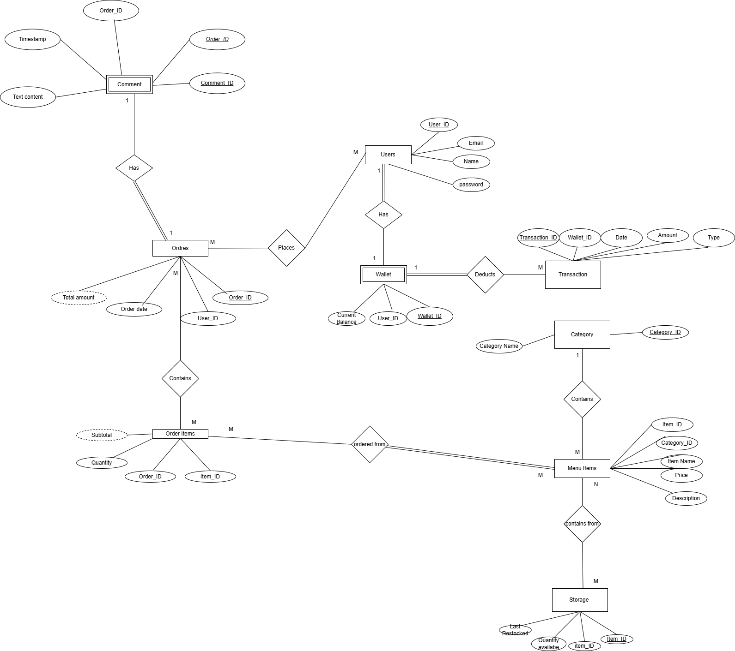
ERD Diagram for the database:-

